# Project 3 — DevOps (Implementation)

**Project 3: Host a static website using AWS S3 bucket.**

Tools Used:  
1. AWS S3 bucket.  
2. AWS Route53

Implementation:  
1. Created an S3 bucket with public access.  
2. Upload the code to the bucket.  
3. Host it by enabling, “Static Website Hosting”.  
4. Give access to the objects that are in the S3 bucket, by editing “Bucket Policy”.  
5. It will generate a link to access the static website.  
6. Using Route53, we can connect it to a specific domain name.

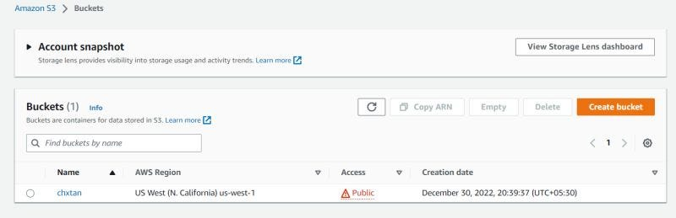

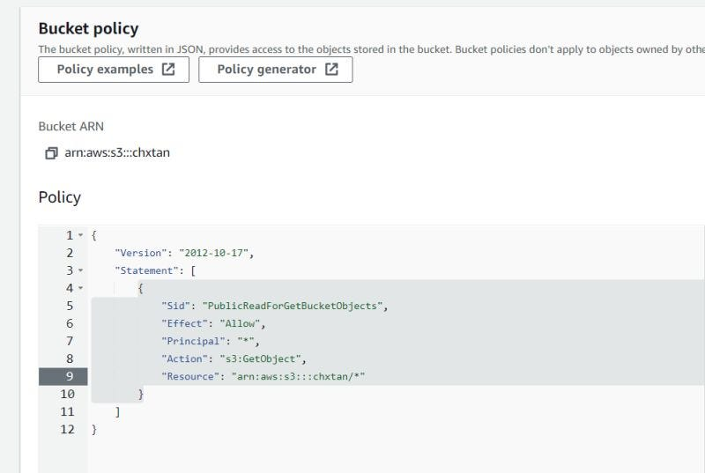

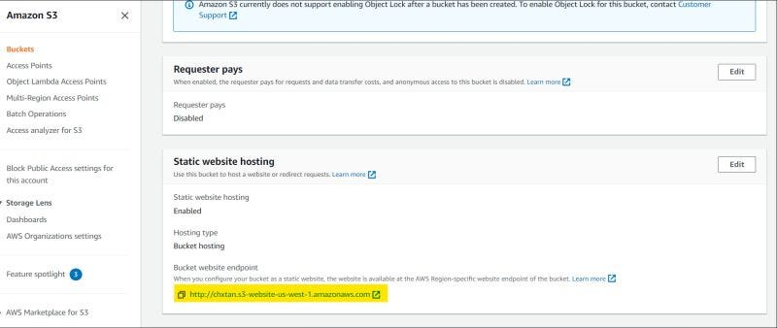

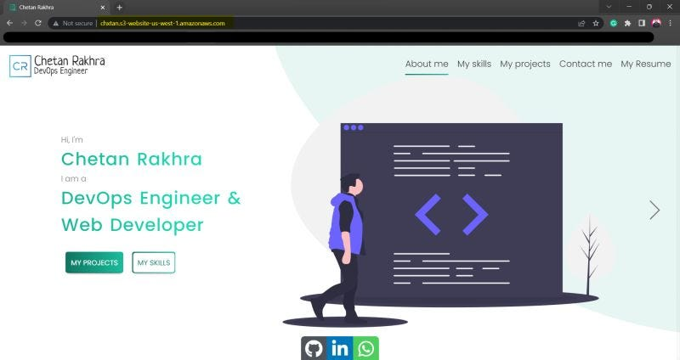

Thanks